**Exercise_No:13**

**Date:23-11-2020**

**Aim:**

**To print the output for the given program using python**

**Program:**

**class Apparel:**

**counter=100**

**def __init__(self,price,item_type):**

**Apparel.counter+=1**

**self._item_id=item_type[0]+str(Apparel.counter)**

**self._price=price**

**self._item_type=item_type**

**def calculate_price(self):**

**self._price+=self._price*0.05**

**def get_item_id(self):**

**return self._item_id**

**def get_price(self):**

**return self._price**

**def get_item_type(self):**

**return self._item_type**

**def set_price(self,price):**

**self._price=price**

**return self._price**

**class Cotton(Apparel):**

**def __init__(self,price,discount):**

**super().__init__(price,'Cotton')**

**self._discount=discount**

**def calculate_price(self):**

**super().calculate_price()**

**price=self.get_price()**

**price-=price*(self._discount/100)**

**price+=price*0.05**

**self.set_price(price)**

**return price**

**def get_discount(self):**

**return self._discount**

**class Silk(Apparel):**

**def __init__(self,price):**

**super().__init__(price,'Silk')**

**self._points=None**

**def calculate_price(self):**

**super().calculate_price()**

**if(self.get_price()>10000):**

**self._ponits=10**

**else:**

**self._points=3**

**return self.set_price(self.get_price()+(self.get_price()*0.1))**

**def get_points(self):**

**return self._points**

**silk=int(input())**

**cotton=int(input())**

**discount=int(input())**

**a=Silk(silk)**

**print(a.calculate_price())**

**b=Cotton(cotton,discount)**

**print(b.calculate_price())**

**Link:**

[**http://103.53.53.18/mod/vpl/forms/submissionview.php?id=328&userid=1684#**](http://103.53.53.18/mod/vpl/forms/submissionview.php?id=328&userid=1684#)

**Output:**

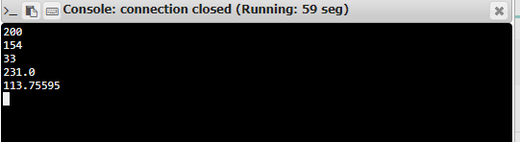

**Result:**

**Thus, the output for the program is successfully executed.**